**Meeting Minutes**

**Agenda:** Requirements Gathering.

**Project Title:** Second Trust

**Project Owner:** Amad Irfan (2021-CS-25)

**Project Developer:** Subhan Anjum (2021-CS-13)

**Discussion:**

As a owner i give complete overview about the requirements or project to me developer, what he have to do in project the requirements are followings.

Based on the meeting agenda and the provided project description, here are the requirements for your "2nd Trust" Second-hand Goods Buying and Selling Platform:

* **User Authentication:**

1. Users can register and log in using either email or phone authentication.

* **Product Listing:**

1. Users, including shopkeepers and customers, can post products for sale with details such as pictures, price, and a short description.
2. Shopkeepers can upload multiple pictures for a single product.
3. Shopkeepers can distinguish between brand new and used items when listing products.

* **User Dashboard:**

1. Registered users have access to a dashboard to view details like product history, visited products, and earned coins.

* **Coin Management:**

1. Users earn coins after selling products.
2. After accumulating a certain number of coins, users can purchase products at a discount.

* **Payment Management:**

1. Implement payment management for both shopkeepers and customers.
2. Integrate the Stripe payment gateway for processing payments.

* **Location Tracking:**

1. Users must add their location when listing a product.
2. Customers can view the location of product sellers.

These requirements cover the essential functionalities needed for your "2nd Trust" Second-hand Goods Buying and Selling Platform.

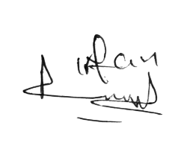

**Developers Signatures:**

**Owner Signatures:**

**Meeting Minutes**

**Agenda:** Requirements Gathering.

**Project Title:** Manags Verse

**Project Owner:** Shahbaz Rafiq (2021-CS-16)

**Project Developer:** Amad Irfan (2021-CS-25)

**Type of Meeting:** Physical

**Location:** Physical Location(Lab 3, Computer Science Department)

**Discussion:**

As a developer I tool complete overview about the requirements, what are the requirements, what he want in his project the requirements are.

* **User Registration & Authentication:**

1. Users can register with their name, email, date of birth, unique name, optional profile image, and password.
2. After registration, a verification email with a 6-digit code is sent for email confirmation.

* **User Portal:**

1. Users can view and read comics and novels in PDF or DOCX format.
2. Comics are categorized under "Comics," and novels are categorized under "Novels."
3. Multiple chapters are available for each comic and novel.
4. Users can see updates, displaying the 10 most recently published comics/novels.

* **Admin Portal:**
  1. Dashboard displaying user activity in the last 24 hours and new user registrations.
  2. Admin can manage publishers and staff (add, update, delete, view).
* **Publisher Portal:**
  1. Publishers can manage comics/novels (add, update, view, delete) with details like name, genre, category, summary, and publication date.
  2. Publishers can manage chapters within comics/novels (add, update, view, delete).
* **Staff Portal:**
  1. Staff can manage users (delete, freeze accounts temporarily or permanently).
  2. Staff can manage user reviews, including the ability to delete reviews with inappropriate content.
* **Non-Functional Requirements:**
  1. Security: Implement API key authentication for data security.
  2. Performance: Ensure fast loading and responsive user interactions.

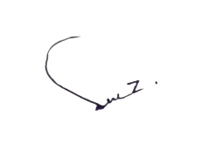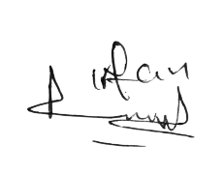

**Developers Signatures:**

**Owner Signatures:**